Lab 02 - Two Dimensional Kinematics
NAME:________________
Time Spent on Lab = approximately three hours, does not need to be done at one sitting

Materials:
Video camera or cell phone camera
ball or similar object to throw in the air
ruler
computer with Tracker software installed

Learning Objectives:
- Model projectile motion in multiple forms
- Solve for a projectile’s path given a set of initial conditions

Description:
This week you will continue on with your efforts in video analysis, in a physics contest. Additionally, you will apply these video analysis skills to a moving projectile, or an object thrown in the air. You may consider asking a friend to help with the video recording, to make the process go a bit smoother. The recording should only take 5 minutes. To better understand a fundamental principle in physics (all objects fall at the same rate on Earth), we will be fitting the video data with functions to illustrate the mathematical behavior of an everyday action.

- Thinking back to the first lab experiment and your idea for a video project to create a lab around. Does the video already include vectors in two dimensions? If so, describe this below.

Exercise #1:
To experiment with what is involved in two dimensional video analysis:
- Measure the diameter of a ball. Any old ball or item that is not essential will work.
- Move to a location where you have ample space to perform an experiment without breaking anything!
- Arrange for a video to be taken of you throwing the ball straight up into the air. Do not throw it in an arc, simply toss, straight up, and back down to your hand.
- Open this video in Tracker, on your computer. Generally students simply email the video to themselves and then open it on their computer via email. Ask the instructor for assistance if you are having trouble opening the video in Tracker.
- After your video is loaded, be sure to setup the scale, from the ball diameter, and the axes, similar to what you did last week.
- Once you have the file setup, click on the ball, or whatever you used, throughout each frame of the video.
- Once you have your data for each frame, you will notice a data table at the bottom of the Tracker window. Click on the “Table” button as depicted below. Then choose to display t, x, y, vx, vy, ax, and ay.
- 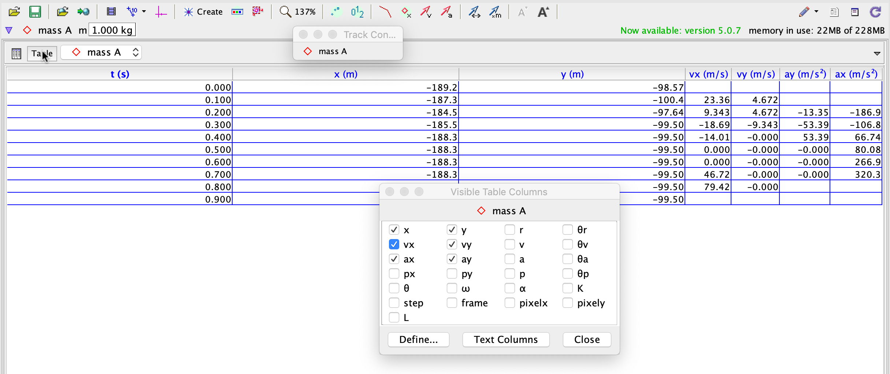

2. You may notice that your velocity and acceleration data do not start in the first frame. Why do you think that is?

3. Keeping in mind that the x values are the horizontal direction, what summary analysis can you make about the position, velocity, and acceleration values in the x direction?

4. You can do this next part in any plotting software, Google spreadsheets/Excel/whatever you are most comfortable with. Graph the data of y versus time, v_{y} versus time, and a_{y} versus time. Then fit a quadratic function to the position graph, linear function to the velocity graph, and linear function to the acceleration graph. Copy those graphs and functions below.

5. Describe the physical significance of the coefficients (actual numbers) in each of the three equations. You might consider looking up the constant acceleration equations in the text!!

6. Sketch a graph of y versus t and y versus x in the space below. Then compare and contrast the shapes of the two graphs.

7. Looking back at the equations for the graphs, do any of the parameters (numbers) or variables in the equations represent mass? Explain your conclusions.

8. Describe how the acceleration varied over time, using each of the three graphs in your description.

Exercise 2: TWO DIMENSIONS:
Introduction -
Now it’s time to complicate matters. You should repeat the same procedures listed in Exercise #1, steps #1-#8. Only now you should throw a ball across a room, field, outdoor play area, or someplace where you have plenty of room in case you do not have very good aim! Some things to keep in mind:
- BE SAFE! Do not throw a ball at something, or someone!, breakable.
- Throw the ball across a few meters, or more, to make sure you can take video for a long enough time.
- Get a partner to help take the video or throw the ball. Likely this will be useful.
- Throw the ball up just enough to make an arcing motion, like in the photo below. It is not necessary to throw it REALLY high, simply high enough to see an arcing motion.
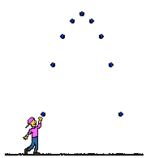

5. Finally, please save this video in a place you can easily find later. You will need it for Lab 06!!!

X-Direction:
9. You can do this next part in any plotting software, Google spreadsheets/Excel/whatever you are most comfortable with. Graph the data of x versus time, v_{x} versus time, and a_{x} versus time. Then fit a linear function to the position graph, linear function to the velocity graph, and linear function to the acceleration graph. Copy those graphs and functions below.

10. Describe the physical significance of the coefficients (actual numbers) in each of the three equations. You might consider looking up the constant velocity equations in the text!

11. Looking back at the equations for the graphs, do any of the parameters or variables represent mass? Explain your conclusions.

12. Describe how the acceleration varied over time, using each of the three graphs in your description.

Y-Direction:
13. You can do this next part in any plotting software, Google spreadsheets/Excel/whatever you are most comfortable with. Graph the data of y versus time, v_{y} versus time, and a_{y} versus time. Then fit a quadratic function to the position graph, linear function to the velocity graph, and linear function to the acceleration graph. Copy those graphs and functions below.

14. Describe the physical significance of the coefficients (actual numbers) in each of the three equations. You might consider looking up the constant acceleration equations in the text!!

15. Looking back at the equations for the graphs, do any of the parameters or variables represent mass? Explain your conclusions.

16. Sketch a graph of y versus t and y versus x in the space below. Then compare and contrast the shapes of the two graphs.

17. Describe the logic of separating the kinematic vectors into their components when solving for projectile motion problems.

18. If your video project idea does NOT include 2-dimensional vectors, then please revamp it to show how you might include the same broad idea you had in lab #1, but now in two dimensions. Feel free to email the instructor should you have questions about this project.

Please download this document as a PDF. Then upload this PDF to Blackboard under the assignment “Lab 02”, for grading.

